**Team 2 Idea Proposal**

Team 2

Names: Kevin, Paul, Aleya, Ty

1. **What is/are the problem/s you want to solve? Why is it important?**

SDGS Target 12.3: By 2030, halve per capita global food waste at the retail and consumer levels and reduce food losses along production and supply chains, including post-harvest losses

We want to encourage Pace/college students to eat more sustainably and to reduce food waste in an effort to reduce pollution resulting from overconsumption of food. This is important because a large part of climate change can be traced directly to the meat production industry and consequences of waste management of food products.

1. **Who are the users you are targeting?**

College students, specifically at Pace University’s Pleasantville campus.

1. **How will this app solve the tackled problem/s? Provide a vision statement.**

Reduce food waste caused by overconsumption by encouraging more sustainable eating through a social competition.

1. **What are the major features of the app?**

Our app will track the calories and macronutrients as well as the carbon footprint of food items available at Pace’s on-campus dining halls. There will be a leaderboard ranking students with the lowest environmental impact for the week & month, with points being awarded weighted toward those who eat most sustainably. There will also be suggestions for sustainable foods to eat available at the dining halls.

1. **What similar apps exist on the market? (at least 5 apps with names, screenshots, links, descriptions and how different they are from what you want to do)**
2. SchoolCafé:
   1. 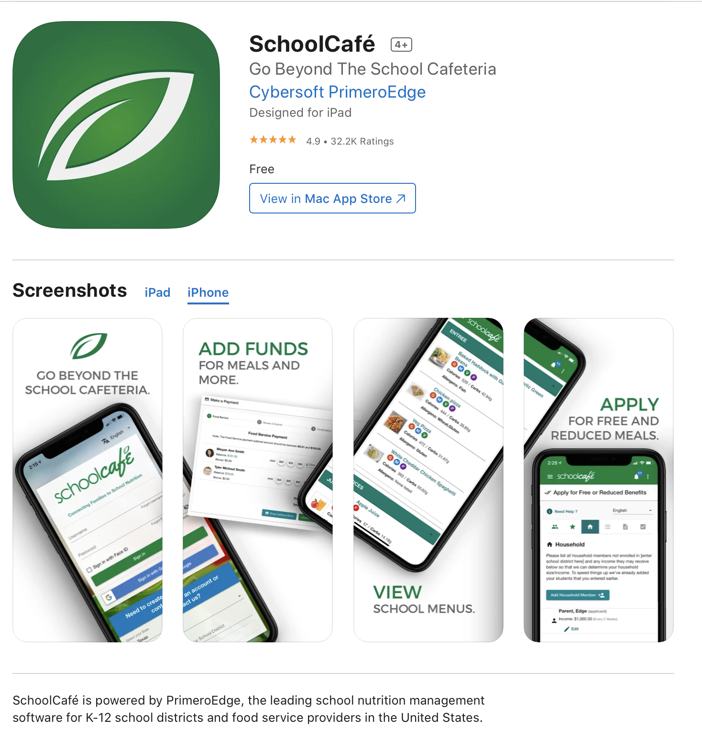
   2. Link: [https://apps.apple.com/us/app/schoolcafé/id1134802301](https://apps.apple.com/us/app/schoolcaf%C3%A9/id1134802301)
   3. This app allows for parents, students, and staff to see what is available on the cafeteria menu each day. It allows each account owner to make payments, view purchase history, and receive low balance alerts. You could also set up alerts for your favorite meals and get notified when those meals are being served. Account owners can also rate the meals.
   4. This app is different from our app because this deals with K-12 schools. Our app is focusing on Pace students. We don't have a set menu like K-12 schools, where they plan out their lunches monthly. Being a college student you need to be responsible to eat three meals a day. Eating at the same place 3 times a day can get difficult. We want to give nutritional options to help students find new meals to eat.
3. GreenChoice: Grocery Shopping
   1. 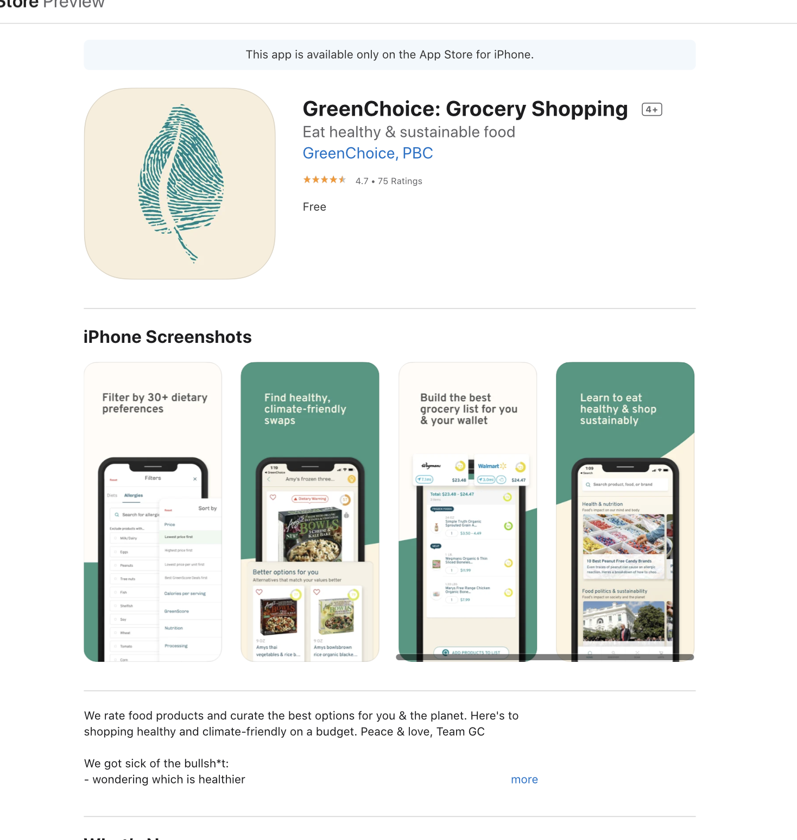
   2. Link: <https://apps.apple.com/us/app/greenchoice-grocery-shopping/id1455716794>
   3. This app helps people grocery shop for food that are both healthy and climate-friendly. This app helps users find foods that are available to them and makes use of how healthy and sustainable the foods are.
   4. This app is different from our app because our app is focussed on food that Pace offers and this app is focussed on food offered at the Grocery store. This app also takes into account price of the foods and helps users pick the best priced items as well.
4. FoodPrint™ - Nutrition Tracker
   1. 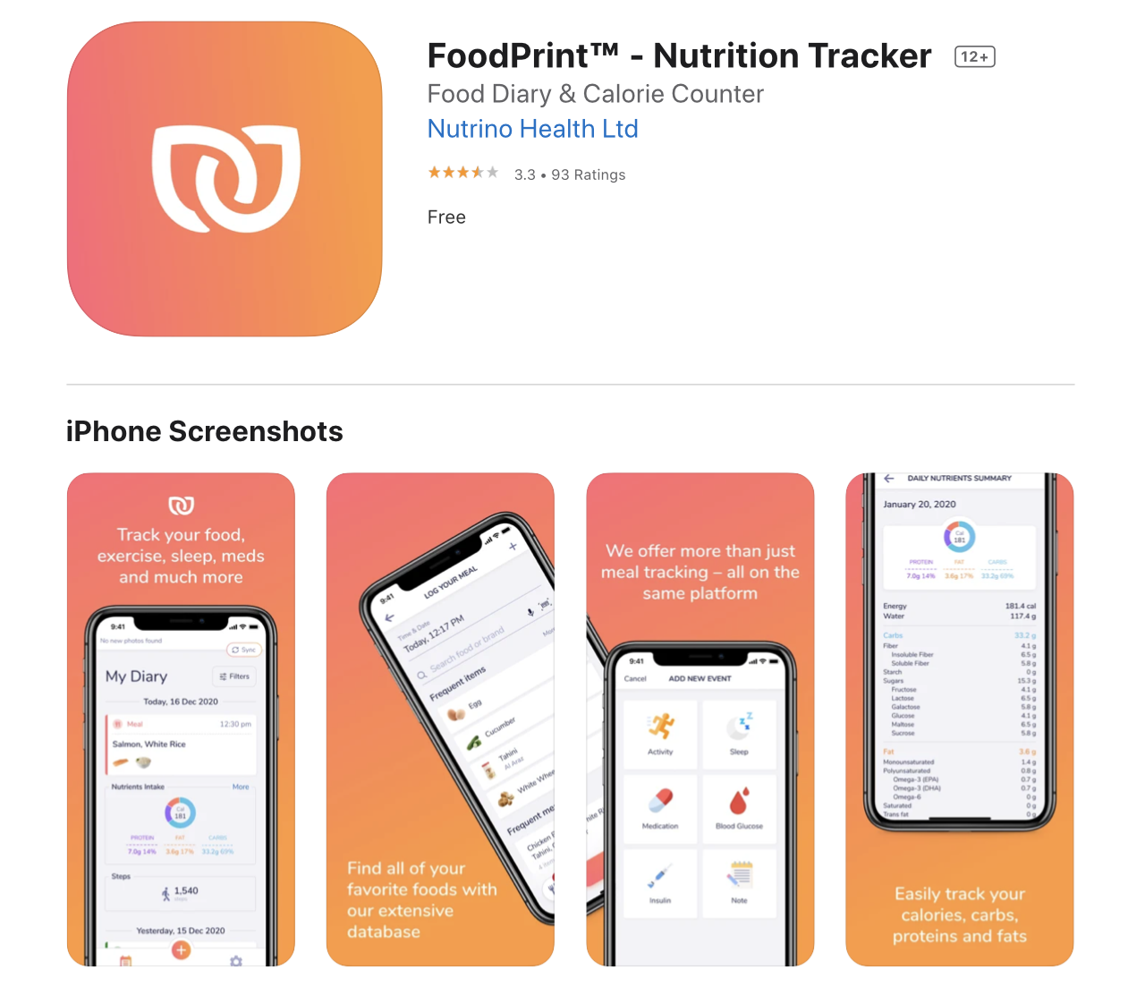
   2. Link: <https://apps.apple.com/us/app/foodprint-nutrition-tracker/id588712321>
   3. FoodPrint™ lets you log your meals and track your nutrients as easily as possible. This app helps you keep track of your health goals. These can include tracking calories, making sure you're eating enough fiber, making sure you get in 30 min of exercises, or diversifying your meals. Account owners will be able to take snap photos of their food and the image will automatically go to their diary.
   4. This app is different from ours because this tracks all of your food. Our main focus is Pace Kessel Cafe and the foods that Pace offers.
5. MyFitnessPal
   1. 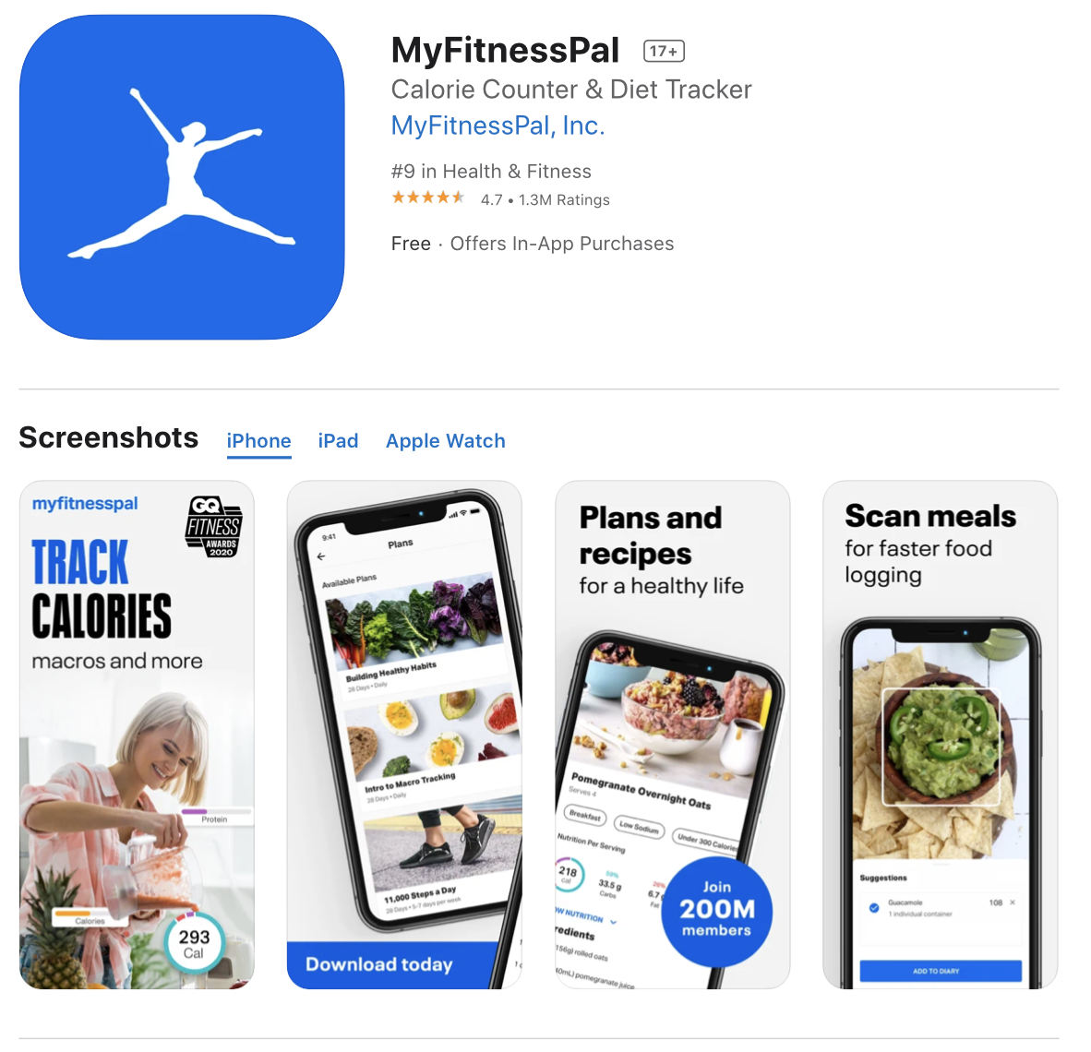
   2. Link: <https://apps.apple.com/us/app/myfitnesspal/id341232718>
   3. This app allows users to keep track of calories and keep track of their weight. Users can scan nutritional information from barcodes, search for foods, or add their own foods. This app helps users set calorie goals to lose, maintain, or gain weight and also has a streak setting so users can see how many days in a row they have logged their foods.
   4. This app is different from our app because our app is going to include the sustainability and the carbon footprint of foods. Our app is also mainly focussing on food from Pace campus because that is what is most eaten by Pace students.
6. Healthy Recipes Magazine
   1. 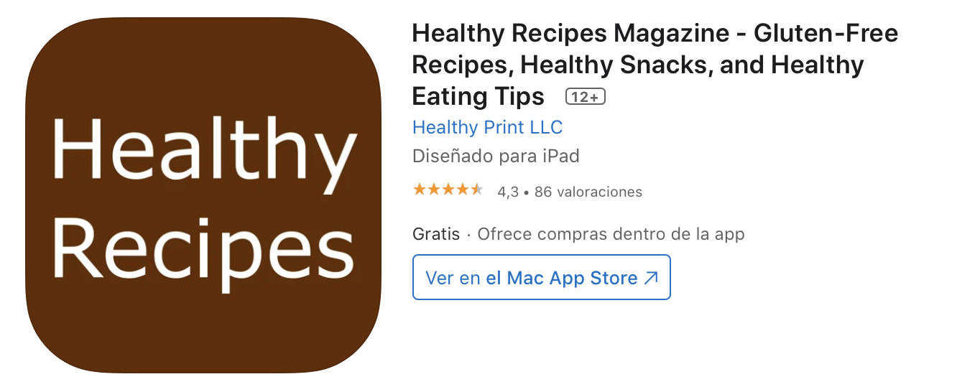
   2. <https://apps.apple.com/us/app/healthy-recipes-magazine-gluten-free-recipes-healthy/id641352460?l=es>
   3. Healthy Recipes Magazine is an app that provides easy, simple and delicious gluten free recipes. They also provide cooking classes, nutrition columns and up to date health science articles.
   4. This is different from our app because they are focused on Gluten free, and they are also providing recipes. We are going to be providing meals. Give students examples of what to get that will be different from what they are used to. We want to help students eat better, give them healthier options.
7. **How is your app unique?**

Users compete against other Pace University students in maintaining a sustainable diet, the app accurately tracks nutritional supplement for each food that the students consume, will work across all dining halls on Pleasantville campus. Nutrition and environmental app that focuses on not only giving the student a healthier lifestyle, but also aiding in reducing the carbon footprint.

1. **What are the risks associated with the development of this app? Why wouldn’t it be delivered completely (scope), on time and on budget? Identify 3 to 5 risks that are relevant in your case.**

We may run into difficulties obtaining accurate information on the nutritional information and carbon footprint of food items at Pace.

Development impediments such as debugging may take up more time than expected and delay the delivery timeline.

It may be difficult integrating the social aspect of the app as we have never worked with networking features before.

1. **What is your goal with this project? (build portfolio/resume, get experience in mobile app dev …)**

Build portfolio/resume, gain knowledge, create an app that people will use for the upcoming future, experience in working in a scrum environment, building leadership qualities, have fun.